*Explain why the algorithm takes O(n).*

Algorithm is time complexity O(n)

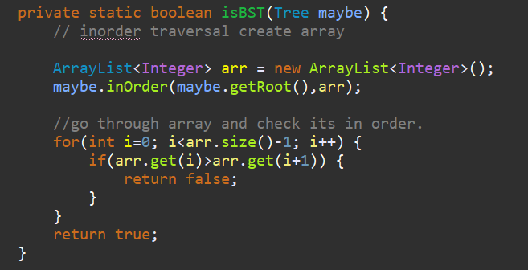

Filling an arraylist with the data keys of the Tree is a process of Time Complexity O(n)

And the for loop that checks if the data keys are in order is a process of Time Complexity O(n)

Because the for loop only iterated over the length of the arraylist once over.

There are no nested loops.

An algorithm with 2 subsequent processes of Time Complexity O(n) , has a time complexity of O(n) itself.